Particle physics: a physics kit

Lesson plan

Note: This plan is not designed for any particular stage of learning, as it is expected to be delivered at any point during the teaching of the particle physics course. Therefore the lesson will always have to be tailored to the needs and prior knowledge of the class, and some slides will need to be ommitted.

First of all introduce the lego. If necessary lay down house rules: no throwing the pieces, and no touching the lego when the presenter is speaking. Anything that is built must be able to exist in the real universe (ie correct numbers of quarks to be a real element or particle), and if the student can’t explain why it is a real thing, it gets destroyed.

There is an accompanying powerpoint to go with the lesson. Try not to let them go through the booklet on their own as they will not think about things, they will just copy the pictures.

Slide 1: Title. Intoroduce the session, and yourself if necessary.

Slide 2: Quarks. Explain the concept of quarks as the smallest thing we have found. The concept of fundamental particles as indivisible. Matter and antimatter. Ask what they notice about down and strange (they have the same charge – explain that it is mass that makes them different).

Slide 3: Generations. Down and strange have the same charge but different masses – strange is like an older sibling of down. Discuss the other three quarks (charm, bottom and top) – these are not normally examinable, but they follow the same pattern as up and down: we have three generations. This pattern is repeated in the lepton family. Discuss leptons as the second type of fundamental particle.

Slide 4: Particle Types. Explain that a hadron is a particle made out of quarks. Quarks don’t like to be on their own (we will find out why later), so tend to stick together. The most common hadrons are protons and neutrons, made of up and down quarks. Ask the students to try to work out how to make a proton, which has a charge of +1. If necessary, give them the hint that there are three quarks in a proton. (They need to work out the combination of three charges which adds to 1). Do the same for neutrons, once they have worked this out.

Slide 5: Mesons and Baryons. Protons and neutrons are both baryons. Can they see the difference between mesons and baryons? Mesons have 2, baryons 3, BUT mesons always include a mix of quarks and antiquarks. If the antiparticle is the exact opposite, can they make an antiproton? An antineutron? Why are there only 2 types, why can’t you have a mix of quarks and antiquarks in a baryon?

Slide 6: Making a hadron. Introduce the concept of colour. Quarks don’t have a fixed color – they can change it at will by emitting gluons (more on that later). But they need to add up to white, and there are only two ways of doing that: in threes (RGB) or in quark-antiquark pairs. Discuss the rules for colour charge and electrical charge. Challenge them to make their own particle zoo. Name particles for them using the octets and nonets and decuplets(see below) or display these after they have made a few.

Optional: If the class is up to it, discuss the possibilities of tetra- and penta-quarks. Very difficult to tell whether it is a real penta quark, or just a baryon and a meson together (demonstrate by holding a lego baryon and meson v. Close and then actually sticking them together). Get them to make their own theoretical particles.

Slide 7: How do we find quarks? We now know why quarks don’t like to be alone. So how do we find them? Discuss quark jets, and how they are formed.

Slide 8: Conservations. So why don’t we see these particles around us all the time? They decay into something more stable: protons or electrons usually. Discuss charge, lepton number and baryon number conservations. Explain the concept of strangeness, and of strangeness conservation.

Slide 9: Decays. Ask them to work out the conservations in Lambda decay. They should be able to see that charge, lepton and baryon numbers are conserved, but not strangeness.

Slide 10: Weak decay. In weak decay, one quark can change flavour – strange or down can change to up (because up is the lightest quark). But this process creates another pair of particles, like the one on the screen.

Option: With advanced classes, weak decay can be worked out using the lego – decay chains can be found at <http://pdg.lbl.gov/2011/tables/contents_tables.html>. This is a good (although high-level) excerise in conserving charge in intractions.

Slide 11: Strong decay. Strong decay conserves strangeness, so quarks are just rearranged to make different things – except a quark-antiquark pair can be created in the reverse process to annihilation, as long as there is enough energy. So you can add particles in, so long as it is a quark antiquark pair, like the ones on the slide. Ask them to work out what a proton-antiproton collision could create (the simplest being three pions).

Slide 12: Quark flow diagrams. Show them he quark flow diagram for beta decay. What force is at work? Ask them to draw their own quark flow diagrams, based on decays and interactions they have looked at – the easiest is the proton to pion interaction from the last slide.

Slide 13: How forces work. Discuss the particle exchange model of forces.

Stand-alone Lego Activities

Use the lego to make different particles, still following the rules of making hadrons (electric and colour charge). Identify and name the particles. See if students can complete the families (pions, kaons, ∑ particles etc.)

Look at decays – ask them to do some strong decays and interactions. Some examples are given below – for example give them a proton antiproton collision. They can work through strong and weak decays and interactions by rearranging the lego in the particles.

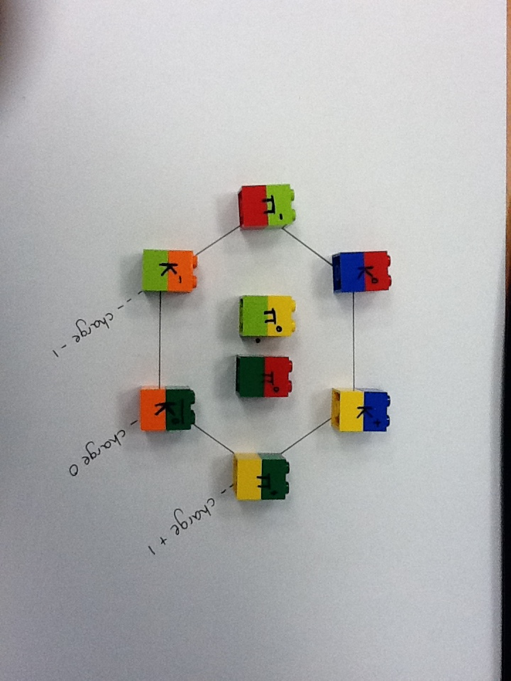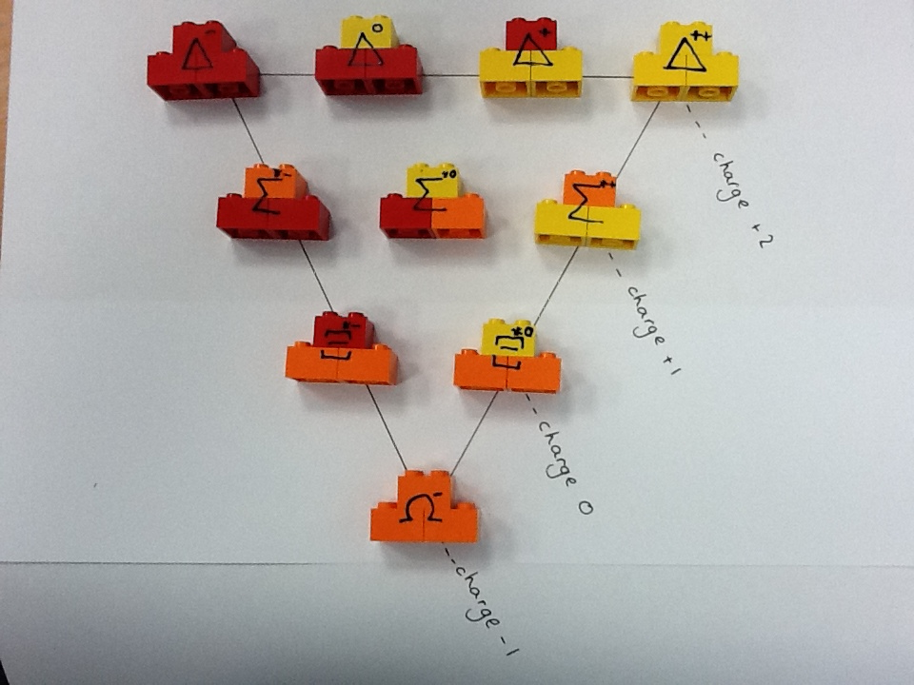Particle identifications

**Mesons**

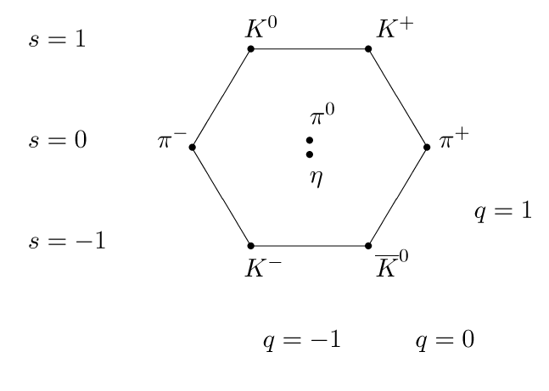

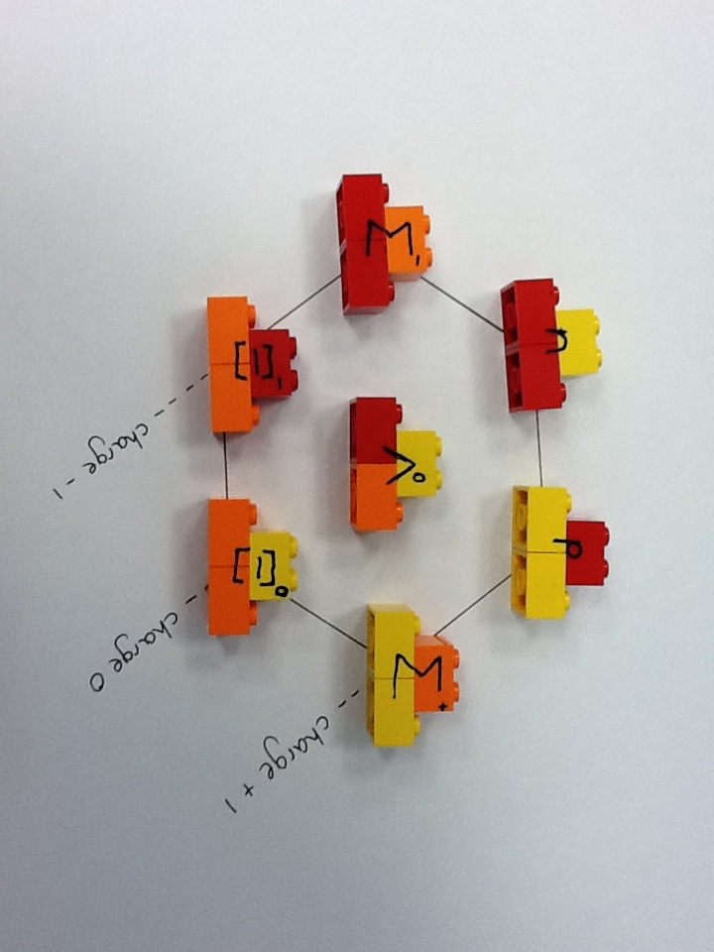

**Baryons**

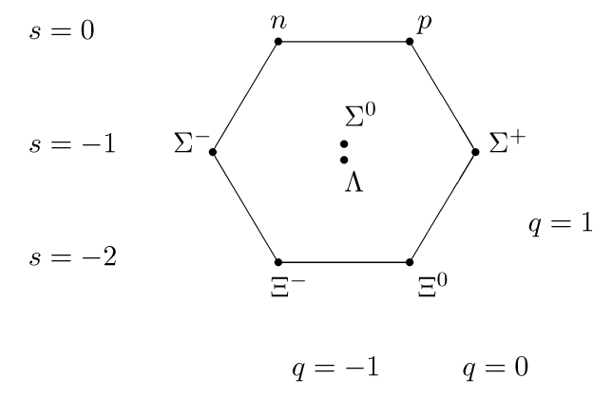Octet

Decuplet

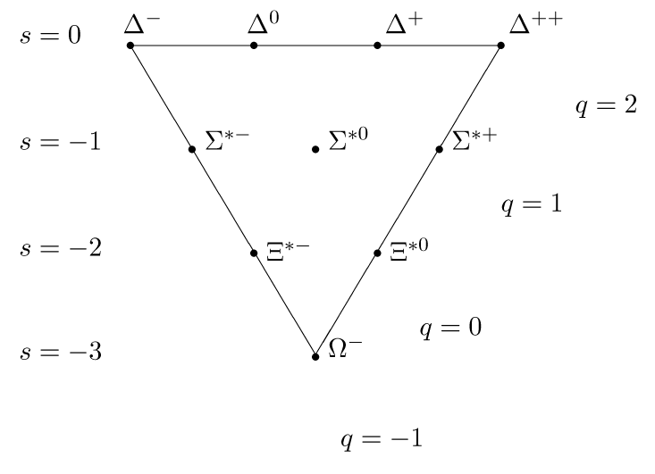These particles have more energy, and hence more mass than the particles in the Octet, even though they are made of the same quarks.

Particle decays and interactions

Strong

Delta decay

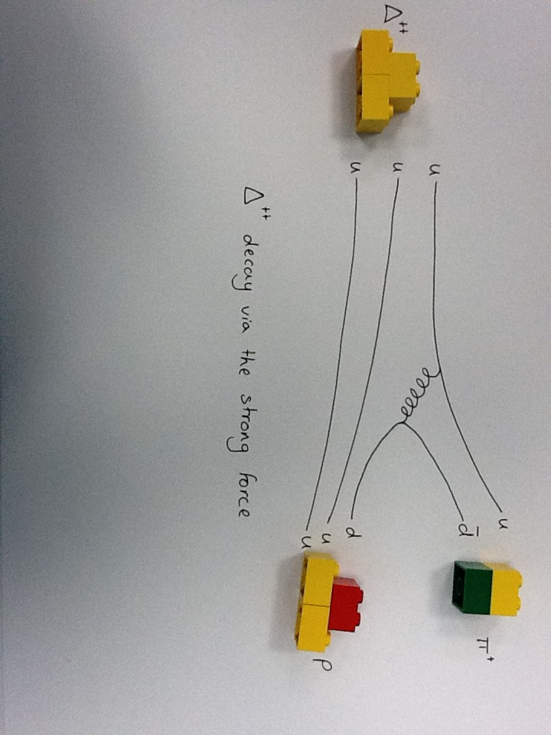

Proton antiproton interactions

